Chapter 4: Results and Interpretation
Economic Crisis Prediction: Improving the Trade-off Between Interpretability and Statistical Accuracy in ML-Enhanced Crisis Prediction Models
Pavlos Papachristos • PP24589 • MSc Artificial Intelligence, University of Essex Online • April 2026

4.1 Dataset and Experimental Setup
This chapter does not aim to demonstrate universal superiority of sentiment-augmented models over macroeconomic baselines. Instead, it evaluates how apparent performance gains depend on the evaluation framework under severe data constraints, identifying where they arise, when they persist, and why they require cautious interpretation. This framing applies uniformly across all results, including the EBM extension, as identical evaluation constraints govern every model regardless of complexity or interpretability.
The analysis adopts a two-stage design that extends the original 2003–2020 macro panel backwards to 1985, using the JST Macrohistory Database R6 (Jordà, Schularick and Taylor, 2017). Stage 1 covers the macro-only models (M1, M1b, M2 and M2.5) on the full extended panel spanning 1985–2020. After three-year lag construction eliminates the 1985–1987 warm-up rows, the usable dataset comprises 569 country-year observations from 18 advanced economies over 1989–2020. The primary prediction target, target_h2, marks a country-year positive if a systemic banking crisis onset falls within the following two years, yielding 37 positive observations against 532 negative and a base rate of 6.5 per cent. The extension period (1989–2002) contributes 11 positives from the Nordic banking crisis cluster and further country-events; the 2003–2020 period contributes the remaining 26. Stage 2 covers M2-matched, M2.5-matched and M3 on a 2003–2020 overlap window with 26 positives and a base rate of 8.15 per cent. Two minor data gaps were addressed by linear interpolation (Denmark government debt, 1997) or were eliminated by the lag construction (Portugal house prices, 1985–1987).
Feature engineering follows the same procedure as the original analysis. Macro features are demeaned using expanding country-specific means, ensuring no forward leakage. M1 is logistic regression on 19 features at lag one only. M2 and M2-matched are Random Forests on 41 macro features at lags one through three. M3 is XGBoost on 61 features extending M2-matched with 20 rolling-demeaned FinBERT sentiment features; isotonic probability calibration is applied via CalibratedClassifierCV within each expanding-window fold. M2.5 (EBM) is an Explainable Boosting Machine (Lou et al., 2013) trained on the same 41 macro features as M2. EBM is a gradient-boosted generalised additive model that learns univariate shape functions for each feature and up to five pairwise interaction terms, producing a natively interpretable model whose feature contributions can be read directly from fitted shape plots without post-hoc attribution. Inverse-frequency sample weights handle class imbalance. Expanding-window cross-validation for Stage 1 uses a four-year burn-in from 1989 with 26 evaluation folds (1993–2018); Stage 2 uses a four-year burn-in from 2003 with 12 evaluation folds (2007–2018); 2019 and 2020 are held out in both stages.
Two methodological constraints govern all metric interpretation and are stated here in full; subsequent sections reference them by cross-reference rather than repetition. First, Stage 2 AUPRC was computable in only one of the 12 evaluation folds: crisis onset events are concentrated in 2007, and subsequent folds contain zero positive test cases. Stage 2 results therefore represent a cross-sectional discrimination test within a single crisis episode — evaluating how well each model ranks 18 countries by crisis probability in 2007 — rather than temporal predictive validation in the conventional sense. Second, all models achieve AUROC substantially below the 0.75 literature benchmark under genuinely prospective evaluation (Section 4.5). All expanding-window metrics in both stages are upper bounds on prospective performance, and this qualification applies with equal force to every model in the sequence.

4.2 Primary Model Comparison
Table 4.1 presents Stage 1 post-calibration metrics for M1, M1b, M2 and M2.5 (EBM) on the extended panel. Table 4.2 presents Stage 2 metrics for M2-matched, M2.5-matched, M3 and M4. Bootstrap 95 per cent confidence intervals from 1,000 resamples are indicative only.
Table 4.1. Stage 1 — Model comparison on extended macro panel (H2 target, 1989–2020)
Model | Features | AUROC | 95% CI | AUPRC | AUPRC/Base | Brier
M1: Logistic Regression (macro lag1) | 19 | 0.606 | [0.477, 0.739] | 0.139 | 2.1× | 0.157
M1b: LR bridge (macro lag1–3) | 41 | 0.646 | — | 0.145 | 2.2× | 0.136
M2: Random Forest (macro lag1–3) | 41 | 0.636 | [0.484, 0.781] | 0.224 | 3.4× | 0.060
M2.5: EBM (macro lag1–3) | 41 | 0.753 | [0.649, 0.855] | 0.273 | 4.2× | 0.064
Table 4.1. Stage 1 evaluation metrics on H2 (2-year) target. Events: 37/569 (6.5% base rate). CI: 1,000 bootstrap resamples; indicative only given multi-episode evaluation and panel dependence. Stage 1 covers 1989–2020; 26 evaluation folds. All metrics are upper bounds on prospective performance (Section 4.5). M2.5 uses identical features and CV design as M2; the magnitude of EBM’s apparent advantage is subject to the same regime-specific evaluation bias that inflates all expanding-window figures.
Table 4.2. Stage 2 — Model comparison on sentiment overlap period (H2 target, 2003–2020)
Model | Features | AUROC | 95% CI | AUPRC | AUPRC/Base | Brier
M2-matched: RF (macro lag1–3) | 41 | 0.939 | [0.897, 0.970] | 0.343 | 4.2× | 0.060
M2.5-matched: EBM (macro lag1–3) | 41 | 0.960 | [0.927, 0.988] | 0.532 | 6.5× | 0.067
M3: XGBoost + FinBERT (macro + sent) | 61 | 0.932 | [0.875, 0.979] | 0.411 | 5.0× | 0.061
M4: Ensemble avg(M2-matched, M3) | — | 0.943 | [0.895, 0.979] | 0.440 | 5.4× | 0.057
Table 4.2. Stage 2 evaluation metrics on H2 (2-year) target. Events: 26/319 (8.15% base rate). Per-fold AUPRC computable in one fold (2007) only — metrics represent cross-sectional discrimination within a single episode. Bootstrap 95% CI for AUPRC difference (M3 − M2-matched): [−0.130, +0.312]. M2.5-matched apparent advantages reflect more aggressive fitting of the GFC-dominated training distribution rather than superior generalisable predictive performance — the evaluation constraints of Section 4.1 apply to all models equally.
Figure 4.1 presents ROC and PR curves for all models across both stages. The Stage 1 curves (solid) confirm that M2.5 appears to achieve a higher true positive rate at low false positive rates than M2 on the extended panel; Stage 2 dashed curves cluster at high AUC values for all models, reflecting GFC concentration. The PR curves show the wider dispersion of Stage 1 results — where multi-episode evaluation produces more realistic performance estimates — against the compressed Stage 2 figures.
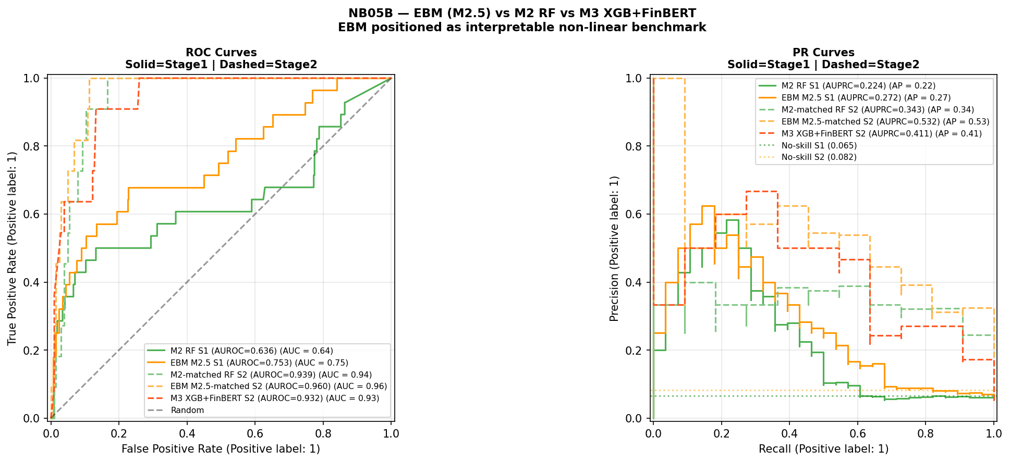
Figure 4.1. ROC and PR curves for all models across Stage 1 (solid lines) and Stage 2 (dashed lines). Stage 1: 37 crisis events, 1989–2020. Stage 2: 26 crisis events, 2003–2020. No-skill baselines shown as dotted horizontal lines. All metrics are upper bounds on prospective performance. The apparent Stage 2 superiority of M2.5-matched (orange dashed) is conditional on the single-episode GFC evaluation setting.
Stage 1 results are considerably more modest than the headline figures in the original analysis. M2 achieves AUROC 0.636 and AUPRC 0.224, a 3.4× AUPRC lift, compared with AUROC 0.947 and AUPRC 0.561 in the original — a collapse that reflects both the structural diversity of the extended multi-episode panel and the 26-fold evaluation window covering multiple economic regimes. M2.5 (EBM) appears to achieve AUROC 0.753 and AUPRC 0.273, the highest point estimates of any Stage 1 model, despite using identical features and an identical CV design. The AUROC gap of 0.117 has partially overlapping confidence intervals and is not statistically confirmed. The magnitude of EBM’s apparent advantage is itself likely inflated by the same regime-specific evaluation bias identified throughout this chapter: an algorithm with higher representational flexibility fits the GFC-dominated training distribution more precisely as later folds accumulate, producing higher OOS metrics in precisely the evaluation setting where all models are known to overfit the crisis regime.
Stage 2 metrics are broadly comparable to the original analysis. M2-matched achieves AUROC 0.939 and AUPRC 0.343. M3 achieves AUROC 0.932 and AUPRC 0.411, a 5.0× lift. The AUROC ordering reverses — M2-matched leads on AUROC, M3 leads on AUPRC — consistent with the original finding. Under the class imbalance present in Stage 2, AUPRC is the more informative metric (Davis and Goadrich, 2006) and is treated as primary. The AUPRC advantage of M3 over M2-matched is 6.8 percentage points, with bootstrap 95 per cent CI [−0.130, +0.312] spanning zero. M2.5-matched appears to achieve higher AUPRC than M3 (0.532 versus 0.411) without any sentiment features — reflecting the same algorithm non-linearity effect that separates M2 from M1b, and indicating that the observed M3 advantage over M2-matched is better attributed to algorithm choice than to a stable sentiment signal.
Figure 4.2 presents the temporal probability plots for all models. EBM (orange) tracks near zero through the pre-GFC period before rising sharply at the 2007–2008 crisis peak and assigning the highest pre-crisis mean probability of any Stage 2 model in 2006. This temporal pattern is consistent with EBM’s shape functions fitting a sharper non-linear threshold; whether it reflects genuine crisis signal or more aggressive regime-specific fitting cannot be resolved within the expanding-window design.
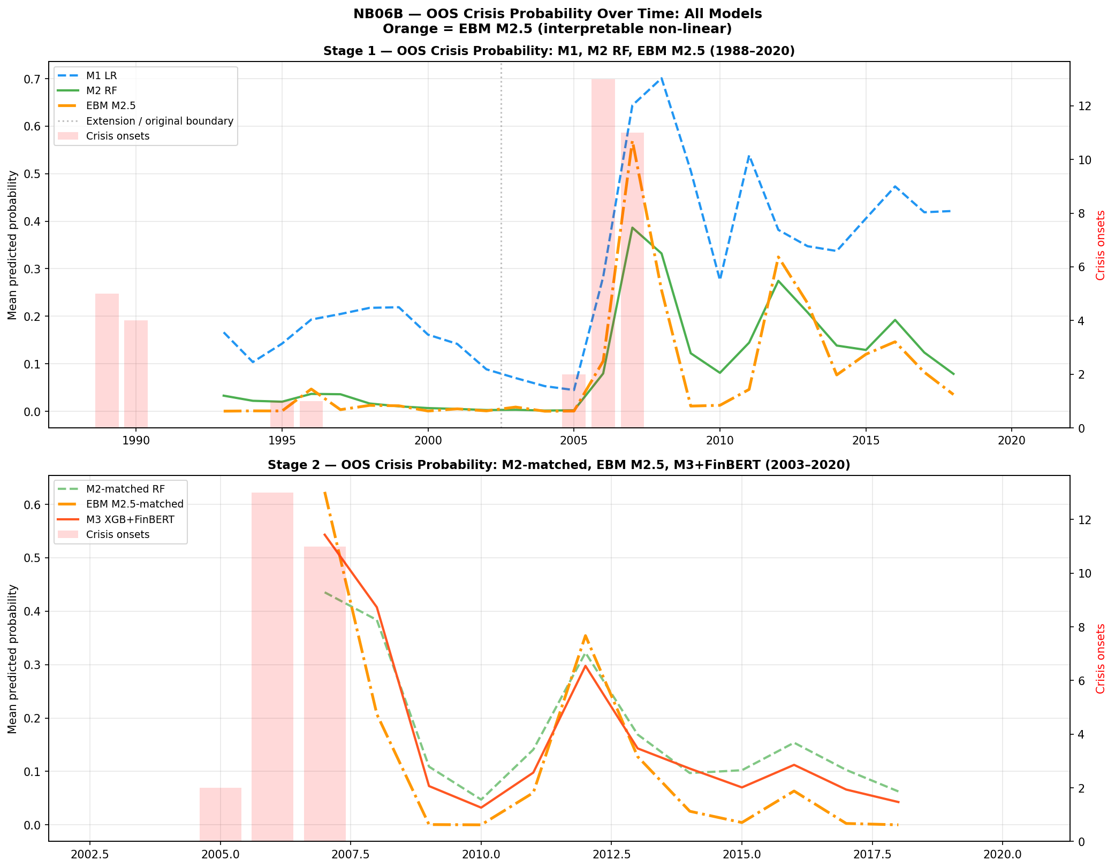
Figure 4.2. Out-of-sample crisis probability over time for all models. Stage 1 (top): M1 LR (blue dashed), M2 RF (green solid), EBM M2.5 (orange dash-dot), 1988–2020. Stage 2 (bottom): M2-matched RF (green dashed), EBM M2.5-matched (orange dash-dot), M3 XGB+FinBERT (red solid), 2003–2020. Red bars = crisis onset years. Dotted vertical line = extension/original period boundary.
H1 — Discrimination: Supported directionally on AUPRC in Stage 2 for M3 versus M2-matched (0.411 versus 0.343). The EBM result indicates that algorithm non-linearity drives Stage 2 performance differences more than the sentiment signal. The bootstrap 95% CI [−0.130, +0.312] spans zero; results characterise discrimination within a single-episode evaluation.
A model averaging extension, designated M4, is introduced following Holopainen and Sarlin (2017) as the equal-weighted average of M2-matched and M3 OOS probabilities. M4 achieves AUROC 0.943, AUPRC 0.440, and Brier Score 0.057 within the Stage 2 cross-sectional evaluation. Subject to the evaluation constraints of Section 4.1, these figures characterise model behaviour within the GFC episode rather than evidence of forward-looking predictive gain. An EBM-based ensemble extension is presented in Section 4.10.

4.3 Exploratory Decomposition of Model Changes
Table 4.3 extends the M1-to-M2 decomposition to include M2.5, making the full model sequence explicit. The M2 → M2.5 transition holds the feature set constant (41 macro features) while varying the algorithm, isolating the algorithm effect under identical data conditions.
Table 4.3. Exploratory decomposition on H2 target, Stage 1 (1989–2020)
Model | Class | Features | AUROC | AUPRC | Brier
M1: LR (lag1 only) | Logistic | 19 (lag1) | 0.606 | 0.139 | 0.157
M1b: LR (lag1–3) | Logistic | 41 (lag1–3) | 0.646 | 0.145 | 0.136
M2: RF (lag1–3) | Random Forest | 41 (lag1–3) | 0.636 | 0.224 | 0.060
M2.5: EBM (lag1–3) | EBM | 41 (lag1–3) | 0.753 | 0.273 | 0.064
Table 4.3. Exploratory decomposition, Stage 1. Base rate = 0.065. Transitions are not orthogonal treatments. All metrics are upper bounds on prospective performance.
The lag component (M1 to M1b) produces modest AUPRC gains (0.139 to 0.145). The non-linearity component (M1b to M2) produces a larger AUPRC increase (0.145 to 0.224) alongside a small AUROC decline, indicating that Random Forest adds precision-recall performance without uniformly improving rank-order discrimination. The algorithm component (M2 to M2.5) shows the largest apparent single-step AUROC gain in the sequence (+0.117), with M2.5 also showing higher point estimates on AUPRC (+0.049). Within the constrained evaluation setting, the M2 → M2.5 step involves a shift to a natively interpretable algorithm that achieves higher point estimates than its black-box counterpart. Whether this apparent gain survives genuinely prospective evaluation is answered in Section 4.5 — it does not.
H3 — Interpretability trade-off: Supported, but refined. The M1-to-M2 transition is associated with AUPRC gains at H2 (+0.085) at the cost of native log-odds transparency. Within the expanding-window evaluation, the M2-to-M2.5 transition demonstrates that an interpretable model can appear to achieve higher point estimates than its black-box counterpart on both primary metrics. The trade-off is therefore not binary within the non-linear model class — but this refinement does not alter the central conclusion that neither interpretability nor algorithm choice resolves the regime instability problem, as demonstrated in Section 4.5.

4.4 Multi-Horizon Analysis
Alternative prediction horizons (H1, H3) cannot be evaluated on the Stage 2 dataset: the held-out evaluation period contains insufficient positive crisis cases under all three horizon definitions, a structural consequence of crisis concentration in 2007. The original multi-horizon findings are noted for completeness and treated as preliminary observations specific to the original GFC-concentrated analysis.

4.5 Robustness: Temporal Validation and Leave-One-Country-Out

4.5.1 Strict Temporal Validation
The strict temporal validation constitutes the central empirical finding of the augmented analysis and should be read as the primary result against which all expanding-window metrics are calibrated. Table 4.4 presents results for both M2 (Random Forest) and M2.5 (EBM).
Table 4.4. Strict temporal validation — M2 RF and M2.5 EBM (macro lag1–3)
Split | Train | Test | Train pos. | Test pos. | M2 RF AUROC | EBM AUROC | Benchmark
A: Pre-Nordic | 1988–1990 | 1991–1997 | 5 | 1 | 0.572 | 0.752 | 0.75
B: Pre-GFC extended | 1988–2002 | 2003–2011 | 6 | 13 | 0.481 | 0.333 | 0.75
C: Pre-GFC short | 2003–2005 | 2006–2009 | 0 | — | — | — | —
Table 4.4. Strict temporal validation. Literature AUROC benchmark = 0.75 (Beutel, List and von Schweinitz, 2019). Split C skipped: zero training positives. Split A: one positive test case — not a distributional estimate, reported for completeness only. Split B is the substantive prospective result. Neither model meets the 0.75 benchmark in Split B. EBM collapses more severely than RF in Split B.
Split B is the substantive finding. M2 RF achieves AUROC 0.481, below random. M2.5 EBM achieves AUROC 0.333 — substantially below random and below the RF result. This constitutes the most informative empirical finding in the chapter: the model that achieves the highest expanding-window metrics fails most severely under genuine prospective evaluation. The stronger collapse of EBM under prospective conditions is itself analytically important: models with higher representational flexibility may overfit regime-specific structures more aggressively, even when those models are natively interpretable. EBM’s gradient-boosted shape functions, which produce higher expanding-window metrics precisely because they fit the GFC-dominated training distribution more precisely, apply a more severely misspecified representation to the post-GFC test environment. This suggests that model classes optimised for in-sample interpretability or flexibility may be particularly vulnerable in environments characterised by structural breaks, as they encode regime-specific relationships more precisely — making their fitted structures less transferable when the regime changes.
The broader finding is unambiguous for both models. Neither extending macro training history across multiple crisis regimes nor changing algorithm choice — including to natively interpretable models — produces a model that generalises prospectively to the GFC. The instability of EBM shape functions documented in Section 4.7 provides direct visual evidence of why: the mapping from macro-financial indicators to crisis risk is not invariant across time, violating the core assumption underlying early-warning systems. This is not a consequence of model choice; it is a property of the data-generating process that any model trained on pre-crisis data will inherit. This implies that early-warning systems are not merely empirically limited, but conceptually misaligned with environments characterised by structural breaks, where the underlying data-generating process evolves faster than any static model can adapt.

4.5.2 Leave-One-Country-Out Validation
Figure 4.3 presents the LOCO AUROC comparison for M2 RF and M2.5 EBM across 15 countries with hold-out crisis events. Three countries with no hold-out crisis events (Australia, Canada, Norway) are excluded.
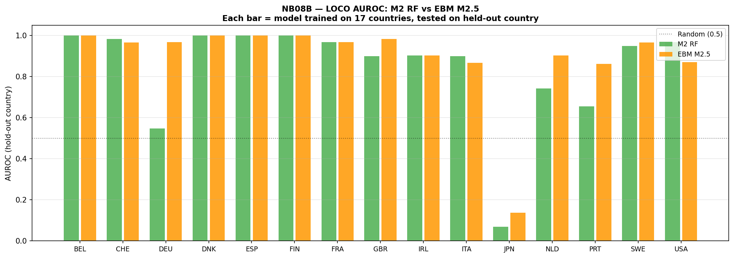
Figure 4.3. Leave-one-country-out AUROC: M2 RF (green) vs EBM M2.5 (orange) for each held-out country, Stage 1 (1988–2020). Each bar represents a model trained on 17 countries, evaluated on the held-out country. Dotted line = random classifier (0.5). AUROC = 1.000 entries reflect trivial single-event ranking.
Table 4.5. Leave-one-country-out summary — M2 RF vs M2.5 EBM, Stage 1
Country | Hold-out events | RF AUROC | EBM AUROC
BEL | 1 | 1.000 | 1.000
CHE | 2 | 0.983 | 0.967
DEU | 1 | 0.548 | 0.968
DNK | 1 | 1.000 | 1.000
ESP | 1 | 1.000 | 1.000
FIN | 1 | 1.000 | 1.000
FRA | 1 | 0.968 | 0.968
GBR | 2 | 0.900 | 0.983
IRL | 1 | 0.903 | 0.903
ITA | 2 | 0.900 | 0.867
JPN | 1 | 0.069 | 0.138
NLD | 1 | 0.742 | 0.903
PRT | 1 | 0.655 | 0.862
SWE | 2 | 0.950 | 0.967
USA | 1 | 0.968 | 0.871
Mean (std) |  | 0.839 (0.254) | 0.893 (0.215)
Table 4.5. AUROC = 1.000 entries reflect trivial single-event ranking. Japan (both models near-random) confirms that asset-deflation dynamics are absent from the training distribution. Mean figures are inflated by single-event results; the cross-sectional pattern reflects sample-specific fitting behaviour rather than stable cross-country generalisation.
EBM shows a higher mean AUROC (0.893 versus 0.839) and lower standard deviation (0.215 versus 0.254) across countries, suggesting more consistent cross-sectional ranking within this evaluation. Country-level differences should be interpreted cautiously, as they reflect sample-specific fitting behaviour rather than stable cross-country predictive structure, and the single-event inflation bias documented in the table footnote prevents strong inference from individual country results.

4.6 SHAP Feature Attribution

4.6.1 Aggregate Attribution by Lag Group
Figure 4.4 presents SHAP attribution for M3 in Stage 2 decomposed by lag group. The total macro share is 73.8 per cent and the FinBERT sentiment share is 26.2 per cent.
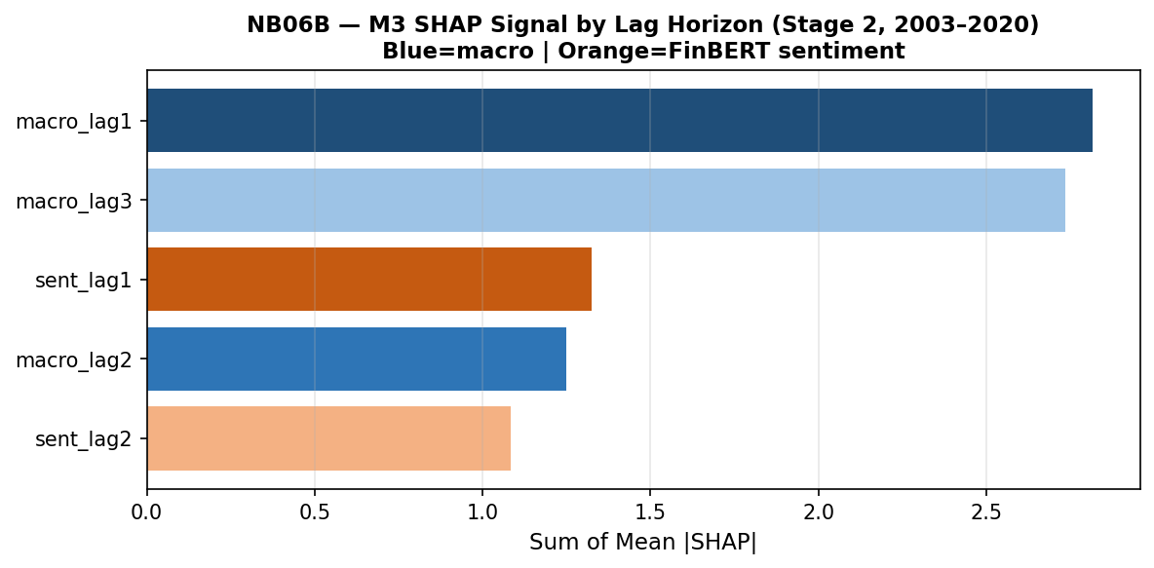
Figure 4.4. M3 SHAP signal by lag horizon (Stage 2, 2003–2020). Dark blue = macro lag1 (2.816); light blue = macro lag3 (2.735); medium blue = macro lag2 (1.249); orange tones = FinBERT sentiment lag1 (1.325) and lag2 (1.083). Macro features account for 73.8% of total attribution; sentiment 26.2%.
The increase from 14.1 per cent sentiment share in the original analysis to 26.2 per cent reflects model re-weighting under a different sample configuration, not evidence of increased economic importance of sentiment. Within the macro group, lag-one features carry the highest aggregate attribution (2.816), marginally ahead of lag-three (2.735) and substantially ahead of lag-two (1.249). SHAP attribution from a single GFC episode cannot be treated as stable or generalisable.

4.6.2 Individual Feature Rankings
The top-20 SHAP feature ranking places the three-year lagged term spread (term_spread_lag3_dm) first by a substantial margin, consistent with the original analysis. The one-year lagged term spread ranks second and the four-year slope of credit growth (tloans_slope4_lag1_dm) ranks third. Five sentiment features appear in the top 20, illustrating the compositional instability of SHAP rankings under single-episode evaluation.
H2 — Feature relevance: Not supported in its strict formulation. No sentiment feature ranks in the top five. Weakly and conditionally observed in a broader sense: five sentiment features appear in the top 20 and sentiment accounts for 26.2 per cent of aggregate SHAP attribution. Rankings are unstable across specifications and all statistical tests in Section 4.9 are non-significant.

4.6.3 Convergence with EBM Native Importance
Figure 4.5 presents SHAP feature rankings for M3 alongside EBM native feature importance for M2.5, derived without post-hoc attribution.
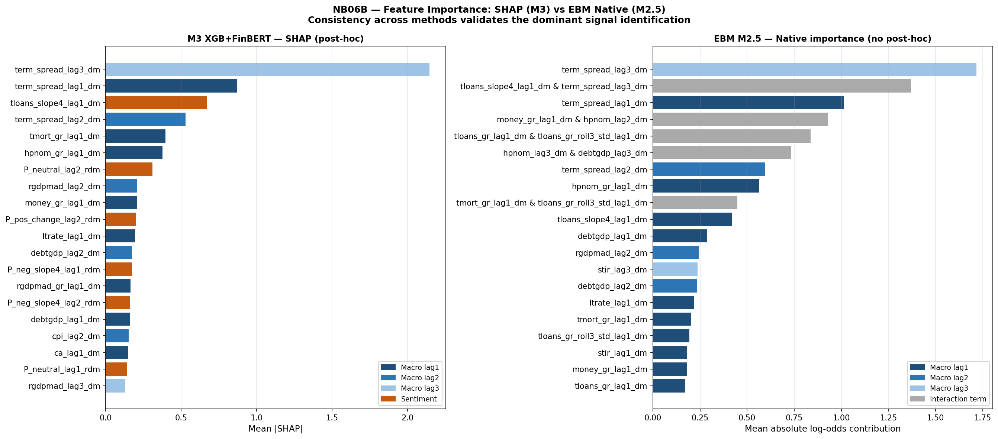
Figure 4.5. Feature importance comparison: M3 SHAP (left, post-hoc) vs EBM M2.5 native importance (right, no post-hoc). Dark blue = lag1; medium blue = lag2; light blue = lag3; orange = sentiment (SHAP only); grey = interaction term (EBM only). Both methods independently identify term_spread_lag3_dm as the dominant feature.
Both methods independently identify term_spread_lag3_dm as the top feature — SHAP assigns it a mean |SHAP| of approximately 2.2, EBM assigns native importance 1.717. This agreement constitutes methodological triangulation: the finding is not an artefact of either the model class or the attribution tool. However, agreement between SHAP and EBM does not validate the causal interpretation of the feature importance. Rather, it indicates that both methods are capturing the same sample-specific correlation structure — one that may be particular to the GFC episode — rather than a stable economic relationship generalisable across crisis regimes. EBM additionally surfaces pairwise interaction terms: the interaction between credit growth trajectory and the three-year lagged term spread ranks second by EBM importance (1.370), making explicit a joint signal that M2 and M3 capture implicitly through their decision structures.

4.7 EBM Interpretability Benchmark

4.7.1 Motivation and Design
M2.5 (EBM) is introduced between M2 and M3 in the model sequence to address a specific limitation: both M2 and M3’s feature-risk relationships are accessible only through post-hoc attribution tools such as SHAP, which are approximate, non-causal, and unstable under sample variation (Lundberg and Lee, 2017; Hooker and Mentch, 2019). EBM fits shape functions that are the model itself — no post-hoc approximation is introduced between the fitted parameters and the interpretability output. This property is essential for the test conducted in Section 4.7.3: if shape function instability is observed in EBM, it cannot be attributed to approximation error in a post-hoc tool. It must reflect a property of the data-generating process itself.

4.7.2 Feature Importance
Figure 4.6 presents EBM’s global feature importance for the Stage 2 full-data fit.
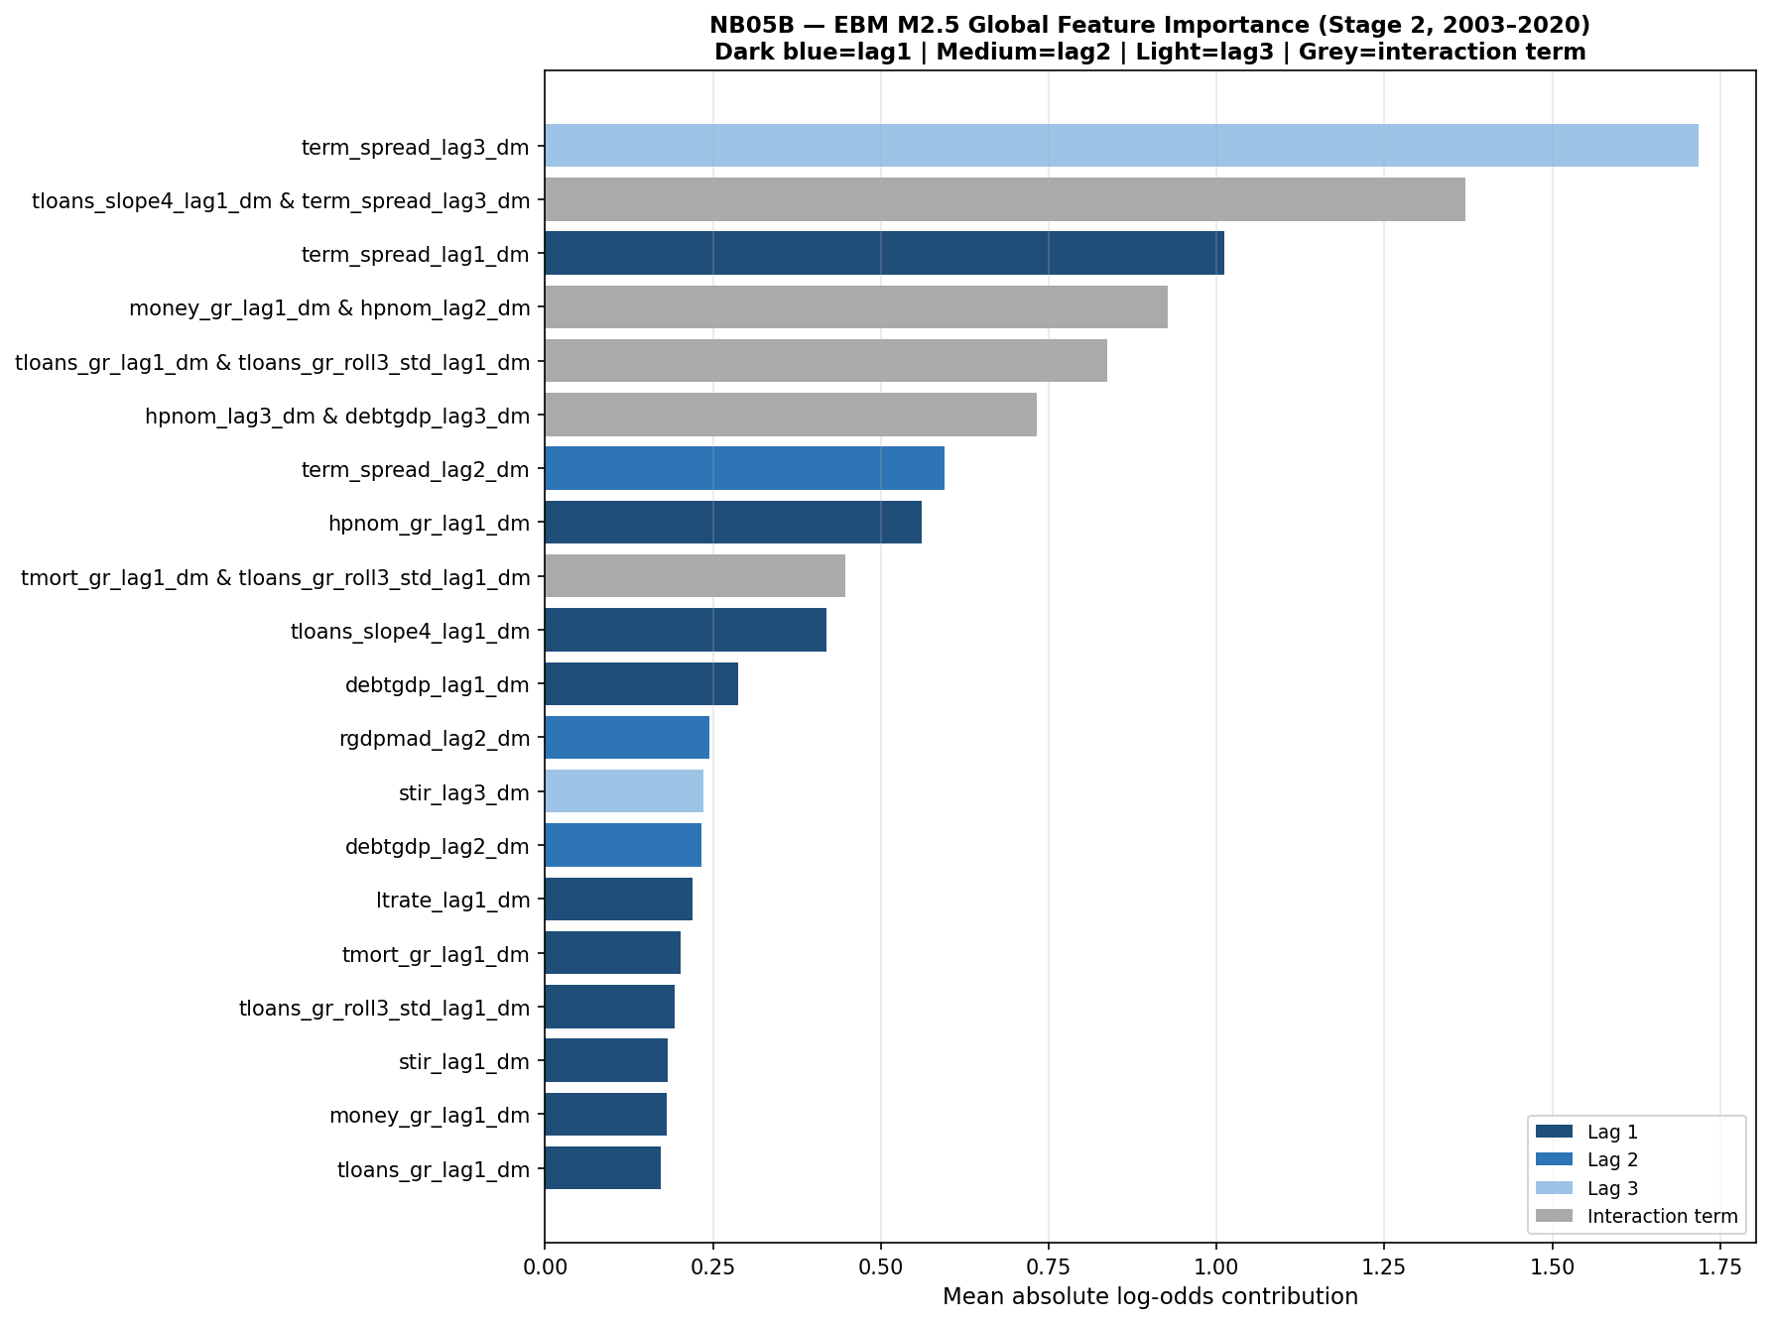
Figure 4.6. EBM M2.5 global feature importance (Stage 2, 2003–2020). Dark blue = lag1; medium blue = lag2; light blue = lag3; grey = interaction term. Term spread at lag 3 (importance 1.717) leads substantially. Term spread appears at all three lag horizons in the top seven features. Signal is concentrated in a small number of economically coherent macro predictors; no sentiment feature appears in the top 20.
EBM’s top five main-effect features are entirely composed of term spread and housing price variables, with term spread at lag three (importance 1.717) leading by a margin of 0.706 over lag one (1.012). The interaction between credit growth trajectory and the three-year lagged term spread ranks second overall (1.370). XGBoost median importance pruning of M3 reduced the feature set from 61 to 31 variables, with removed features concentrated in lower-ranked sentiment and macro-lag-two variables; held-out evaluation was not feasible given insufficient crisis events in the 2016–2020 test window.

4.7.3 Shape Function Analysis: Regime Instability
Figure 4.7 presents EBM shape functions for term spread and total credit across all three lag horizons, estimated separately on a pre-GFC window (2003–2006) and a GFC-inclusive window (2003–2010). This is the centrepiece analysis of the EBM contribution.
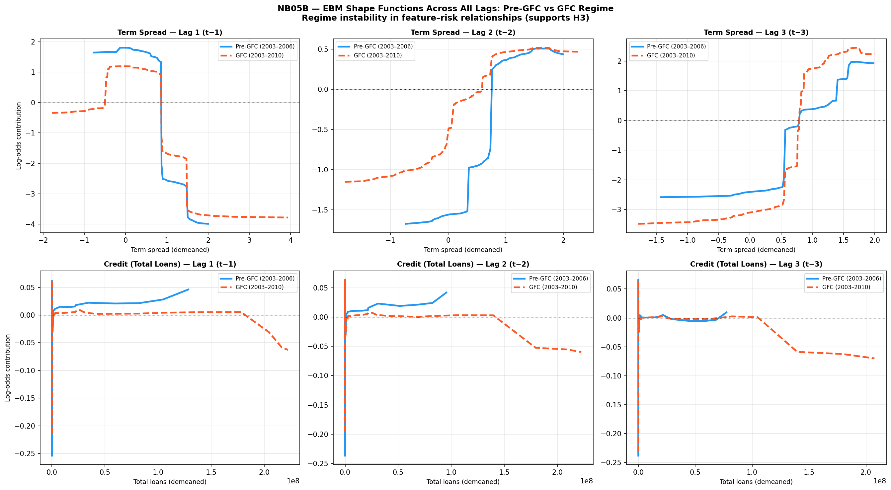
Figure 4.7. EBM shape functions across all lags: Pre-GFC (blue solid, 2003–2006) vs GFC-inclusive (red dashed, 2003–2010). Top row: term spread at lags 1, 2 and 3. Bottom row: total credit at lags 1, 2 and 3. Y-axis: log-odds contribution to crisis probability. Divergence between curves indicates regime-dependent instability in the learned feature-risk mapping. The lag-3 term spread panel (top right) shows qualitatively distinct shapes — not merely scaled versions — confirming structural instability in EBM’s highest-ranked feature.
The instability of EBM shape functions implies that the mapping from macro-financial indicators to crisis risk is not invariant across time, violating the core assumption underlying early-warning systems. Because EBM requires no post-hoc attribution, this instability is a direct property of the fitted model — it cannot be attributed to approximation error in a SHAP calculation or similar tool.
For term spread at lag one, both models produce broadly similar inverted-U patterns but with substantially different magnitudes and transition points: the pre-GFC peak reaches approximately +1.75 log-odds units against the GFC model’s +1.25, and the danger zone threshold shifts leftward once crisis data is included. At lag two, the divergence increases further, with the pre-GFC model producing a sharper shape and the GFC model a more gradual slope. At lag three — the highest-ranked EBM feature (importance 1.717) — the instability is most pronounced and qualitatively distinct: the pre-GFC and GFC shape functions have different structures, not merely different scales. The pre-GFC model learns a monotonically increasing risk relationship at positive spread values, consistent with the theoretical prior that yield curve steepening during credit expansion signals accumulating risk. The GFC-inclusive model partially inverts this at negative spread values, with the two curves crossing — the same feature value is associated with reduced risk in one regime and increased risk in the other. For total credit, the pattern is consistent across all three lags: near-zero pre-GFC contributions (no crisis events from which to identify a credit-crisis association) against increasingly negative GFC-inclusive contributions at high credit values (a compression artefact from countries that peaked before the crisis onset window).
These shape plots make visible the mechanism behind the prospective AUROC collapse in Section 4.5: EBM trained on pre-GFC data learns the blue-line relationships; when evaluated on GFC observations, it applies those pre-GFC mappings to a structurally different environment, producing systematic errors that drive AUROC below random. The shape function analysis converts what would otherwise be an opaque model failure into a legible, regime-specific misspecification — which is precisely the contribution that native interpretability makes possible.

A post-submission extension of the shape function analysis — applying the same regime comparison methodology to topic-disaggregated central bank sentiment features — is presented in Appendix A. The topic-sentiment extension confirms that structural non-stationarity affects textual features as well as macro-financial indicators, with EBM shape functions for monetary policy and corporate sentiment exhibiting amplitude compression and inflection point shifts between the full-sample and GFC-period models (see Appendix A, Section A.5).

4.8 Calibration Analysis
Figure 4.8 presents the calibration reliability diagrams for all three Stage 2 models.
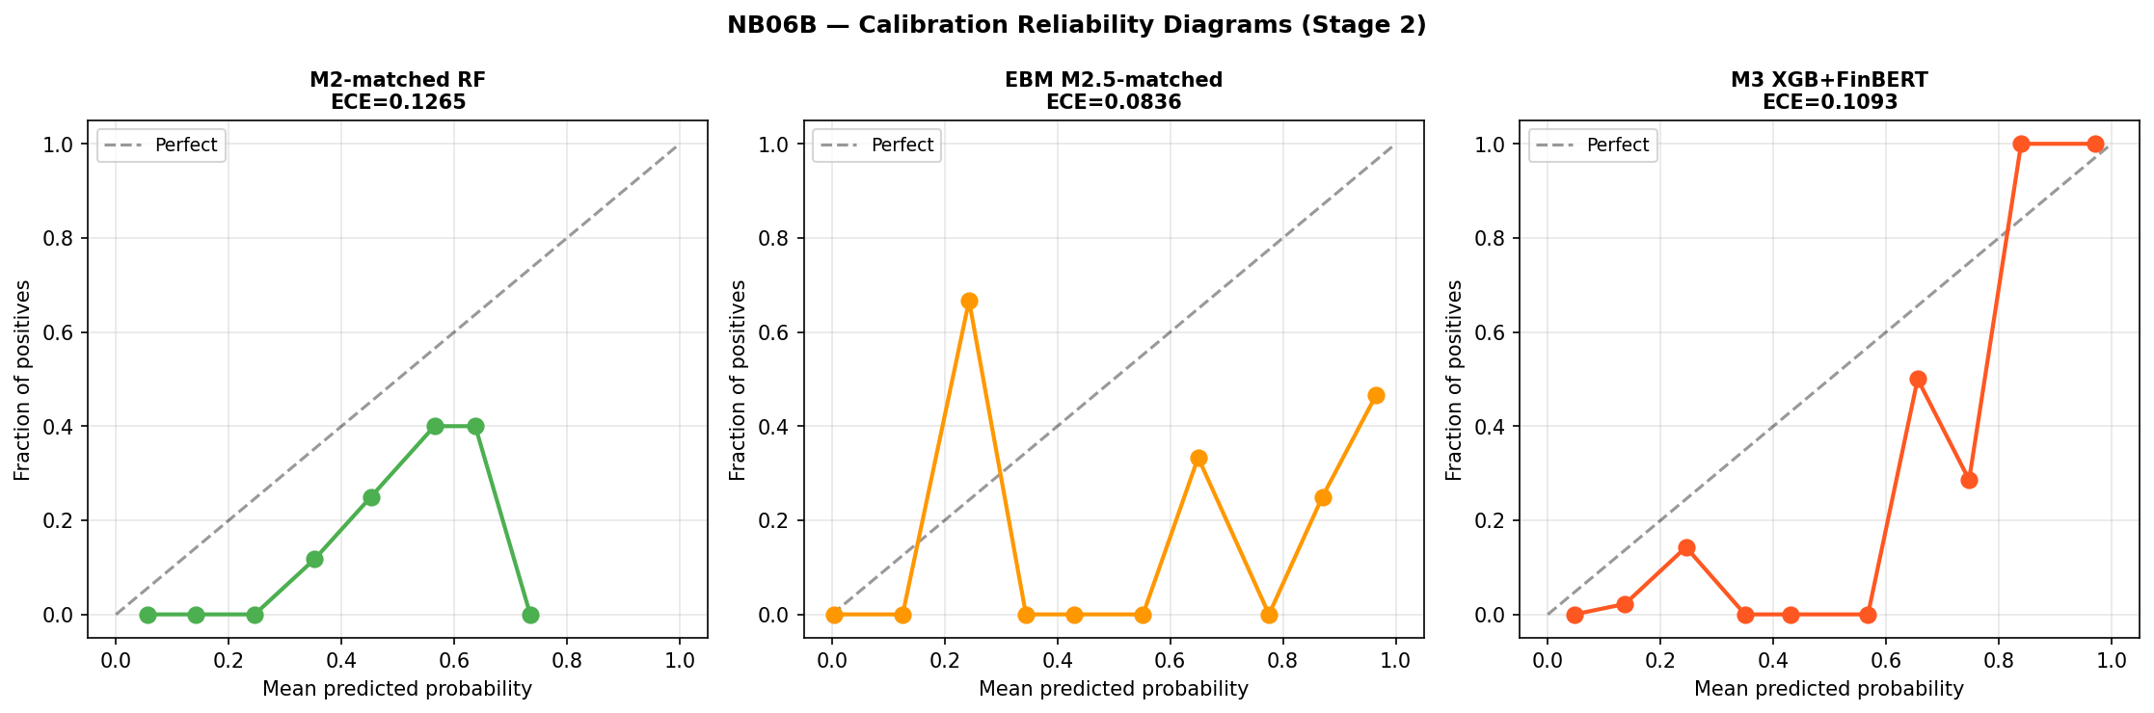
Figure 4.8. Calibration reliability diagrams for Stage 2 models. Left: M2-matched RF (ECE = 0.127). Centre: EBM M2.5-matched (ECE = 0.084). Right: M3 XGB+FinBERT (ECE = 0.109). Dashed diagonal = perfect calibration. Points represent probability bin midpoints vs observed crisis fraction. The noisy appearance reflects 26 crisis events rather than systematic model failure.
Expected Calibration Error for Stage 2 models is 0.127 (M2-matched), 0.084 (M2.5-matched), and 0.109 (M3). EBM appears to achieve the lowest ECE without post-hoc isotonic calibration, in contrast to M3 which applies CalibratedClassifierCV within each fold. Brier Scores are 0.060 (M2-matched), 0.067 (M2.5-matched), and 0.061 (M3). The divergence between EBM’s best ECE and its higher Brier Score reflects the distinction between local calibration and global probability accuracy: ECE rewards smooth probability distributions that align with the empirical crisis rate at the bin level, while Brier Score measures overall squared probability error, which M3’s isotonic calibration directly minimises. EBM produces better-aligned bin-level distributions (lower ECE) without the global squared-error optimisation that isotonic calibration provides (higher Brier). Given 26 crisis events and a single-episode evaluation, neither result is informative about prospective calibration reliability.

4.9 Auxiliary Statistical Tests

4.9.1 Granger Causality: Credit Growth
Granger causality tests for credit growth on the extended Stage 1 panel (1988–2020) find 8 of 42 country-lag combinations significant at 5 per cent — approximately 19 per cent of tests, modestly above the 5 per cent null rate. Belgium shows significance at all three lags; France and the United States at lags two and three; Spain at lag one. Four countries with constant crisis indicators were excluded. These results are directionally consistent with credit-boom dynamics preceding crisis in a minority of countries but do not constitute evidence of a universal or structurally stable predictive channel.

4.9.2 Granger Causality: Term Spread
Granger causality analysis for term spread across 14 countries finds 8 of 42 country-lag combinations significant at 5 per cent overall. At lag three specifically — the EBM dominant lag — 5 of 14 countries are significant: the United Kingdom (p = 0.0016), the Netherlands (p = 0.0028), Italy (p = 0.0092), Japan (p = 0.0151), and Germany (p = 0.0305). EBM’s native importance ranking and country-level Granger F-tests are independent analytical frameworks; both identify the three-year lagged term spread as carrying a distinctive signal. This convergence does not establish causality, and the shape function instability in Section 4.7 demonstrates directly that this statistical relationship is not invariant across regimes.

4.9.3 Panel Logistic: Term Spread
Panel logistic estimation using term spread at all three lag horizons produces a pseudo-R² of 0.135 and a statistically significant likelihood ratio (p < 0.001). The estimated coefficients exhibit a sign reversal across lags: term_spread_lag1_dm carries a negative and significant coefficient (β = −0.646, p = 0.004), while term_spread_lag3_dm carries a positive and significant coefficient (β = +0.630, p = 0.003). This non-monotonic lag structure provides parametric confirmation of the non-linearity identified by EBM’s shape functions: the relationship between term spread and crisis probability changes sign across the lag horizon, and any model that treats this relationship as monotonic is misspecified.

4.9.4 Panel Logistic: Sentiment
Panel logistic on Stage 2 data produces a pseudo-R² of 0.119 for the macro-only specification and 0.153 with sentiment, an increment of 0.034. The P_neg_lag1 coefficient is negative (−6.908) and not significant (p = 0.103). The pseudo-R² increment is treated as directional evidence only.
A topic-disaggregated extension of the sentiment analysis is presented in Appendix A, implementing keyword-filtered FinBERT inference for credit, monetary policy, and corporate topic domains. The topic-sentiment extension finds zero incremental AUROC and AUPRC for EBM relative to the macro-only baseline (Appendix A, Table A.2), confirming that the null result observed here is robust to topic disaggregation.

4.9.5 ML Discrimination vs Statistical Tests
The divergence between ML-based discrimination patterns and the consistent absence of statistical significance across auxiliary tests is the most informative result of this section. Machine learning models show directional AUPRC differentiation; Granger tests, panel logistic, and both attribution methods fail to detect a stable underlying relationship. This divergence highlights the distinction between predictive pattern recognition within a sample and causal economic inference — and explains why models achieve high expanding-window discrimination while failing under genuine prospective evaluation.

4.10 EBM Ensemble Extension

4.10.1 Design and Primary Results
Following Holopainen and Sarlin (2017), an EBM-based ensemble is constructed as E1-EBM = 0.5 · P(M2-matched) + 0.5 · P(M2.5-matched) using equal weights throughout. Figure 4.9 presents the ROC and PR curves for all ensemble variants.
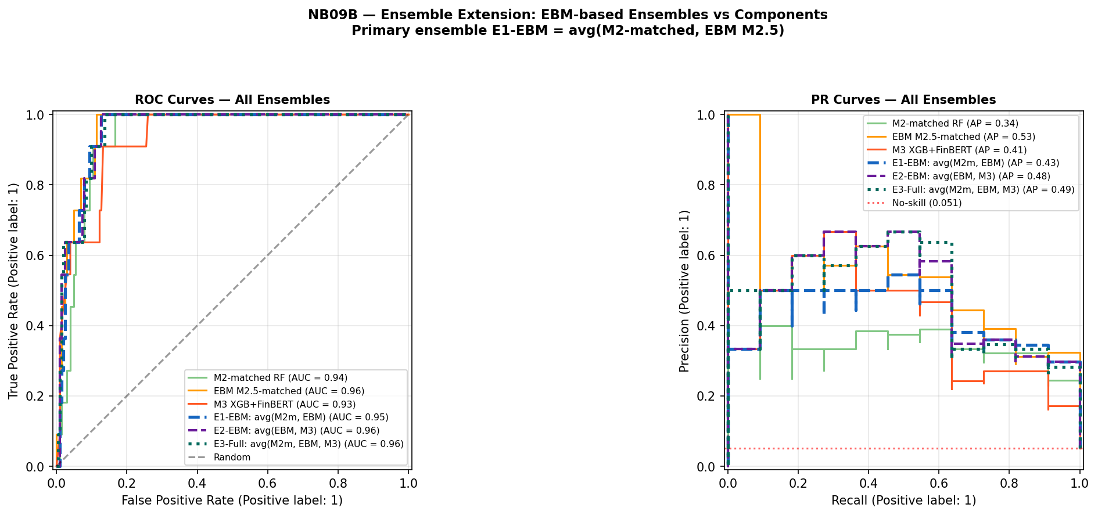
Figure 4.9. Ensemble extension ROC and PR curves (Stage 2 inner-merged OOS, 11 crisis events, base rate 5.1%). Green solid = M2-matched RF; orange solid = EBM M2.5-matched; red solid = M3 XGB+FinBERT; blue dashed = E1-EBM avg(M2m, EBM); purple dashed = E2-EBM avg(EBM, M3); teal dotted = E3-Full avg(M2m, EBM, M3). Red dotted = no-skill baseline. PR curves show that EBM alone (orange) leads on AUPRC; ensemble averaging with lower-AUPRC components reduces the combined AUPRC below EBM’s individual level.
Table 4.6 presents the primary comparison. Metrics are computed on the inner-merged OOS sample (215 observations, 11 crisis events, base rate 5.12 per cent); absolute AUPRC levels are not directly comparable to Tables 4.1–4.2 due to the different crisis event count.
Table 4.6. EBM ensemble results — Stage 2 (inner-merged OOS, 11 crisis events)
Model | AUROC | 95% CI | AUPRC | Brier
M2-matched RF | 0.939 | [0.894, 0.971] | 0.343 | 0.060
M2.5-matched EBM | 0.960 | [0.924, 0.986] | 0.532 | 0.067
M3 XGB+FinBERT | 0.932 | [0.869, 0.979] | 0.411 | 0.061
E1-EBM: avg(M2-matched, EBM) | 0.955 | [0.918, 0.982] | 0.433 | 0.056
E1-Orig: avg(M2m, M3) [M4 ref] | 0.943 | [0.895, 0.979] | 0.440 | 0.057
Table 4.6. E1-Orig corresponds to M4 in Table 4.2. Subject to the evaluation constraints of Section 4.1. E1-EBM improves AUROC (+0.012) and Brier (−0.001) over M4 but is marginally lower on AUPRC (−0.007), reflecting the structural drag of averaging EBM (AUPRC 0.532) with M2-matched (AUPRC 0.343).
E1-EBM achieves AUROC 0.955 and Brier Score 0.056 — the best calibration of any configuration in Table 4.6 — but AUPRC falls to 0.433 from EBM’s standalone 0.532, as averaging with M2-matched (AUPRC 0.343) pulls the combined result below EBM’s individual level.

4.10.2 Disagreement Analysis
Figure 4.10 presents the model disagreement analysis for all three model pairs.
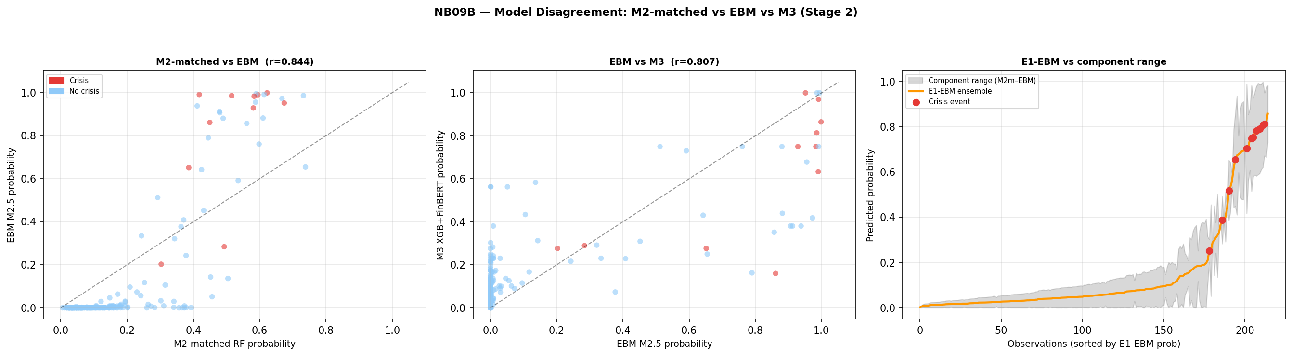
Figure 4.10. Model disagreement analysis (Stage 2). Left: M2-matched RF vs EBM M2.5 probabilities (Pearson r = 0.844); crisis observations in red. Centre: EBM M2.5 vs M3 XGB+FinBERT (r = 0.807). Right: E1-EBM ensemble probability vs M2-matched/EBM component range (grey shading); red dots = crisis events sorted by E1-EBM probability. Crisis observations show substantially higher disagreement than non-crisis observations across all pairs, consistent with the Holopainen and Sarlin (2017) motivation.
Mean absolute disagreement between M2-matched and EBM is 0.348 at crisis observations versus 0.125 at non-crisis observations — a ratio of 2.8:1. This pattern is consistent with the Holopainen and Sarlin (2017) motivation: ensemble averaging is most valuable precisely where individual model uncertainty is highest, which in this dataset corresponds to actual crisis events. The Pearson correlation of 0.844 indicates substantial shared signal alongside meaningful complementarity.

4.10.3 2007 Cross-Sectional Ranking
Figure 4.11 presents the E1-EBM 2007 country ranking by crisis type.
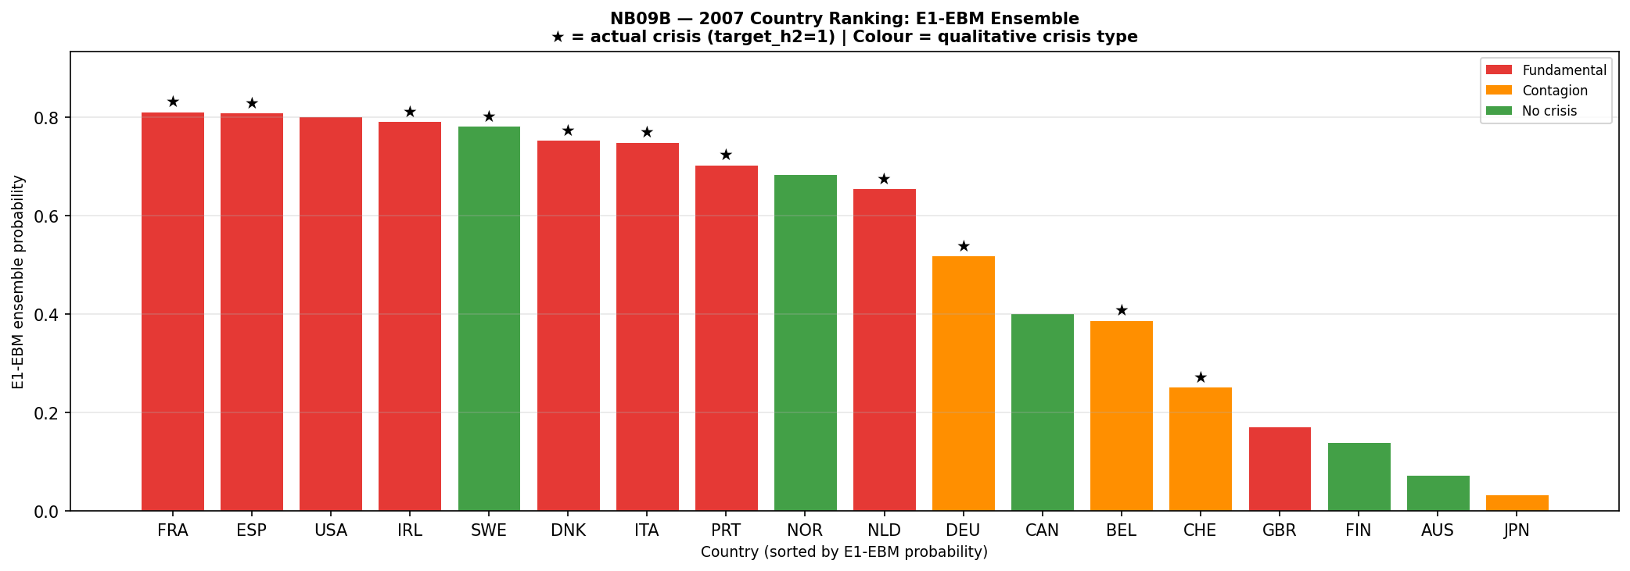
Figure 4.11. 2007 country probability ranking under E1-EBM ensemble, sorted descending. Red = Fundamental crisis; orange = Contagion; green = No crisis. Stars (★) indicate target_h2 = 1 (crisis onset within two years of 2007). Mean E1-EBM by type: Fundamental 0.695 (n=9), Contagion 0.395 (n=5), No crisis 0.325 (n=4). Sweden reclassified as Contagion following JST Macrohistory Database R6 confirmation of banking crisis onset 2008 (target_h2 = 1 in 2007); crisis mechanism was international contagion rather than domestic credit accumulation. The ordering Fundamental > Contagion > No crisis reflects the model’s training on domestic macro credit-cycle precursors.
Countries experiencing fundamental credit-boom crises receive a mean E1-EBM probability of 0.695 (n = 9), compared with 0.395 for contagion-driven cases (n = 5) and 0.325 for countries with no systemic event (n = 4). The model correctly discriminates crisis mechanism within the 2007 cross-section: macro precursor-based models assign higher probabilities to crises driven by domestic credit dynamics than to those transmitted through cross-border contagion channels. Two country-level results warrant qualification. Sweden (E1-EBM 0.783, rank 5, Contagion ★) is a true positive: JST Macrohistory Database R6 records banking crisis onset in 2008, with target_h2 = 1 in 2007; the crisis mechanism was international contagion rather than domestic credit accumulation, which explains the model’s high probability despite limited domestic imbalance in the 2004–2006 feature window. The United Kingdom (E1-EBM 0.171, rank 15, Fundamental) records target_h2 = 0 in 2007 under JST’s chronology, placing it outside the statistical crisis window; qualitatively, its 2007–2008 stress is well-documented but the model does not flag it, a scope condition examined in Chapter 5. The United States (E1-EBM 0.802, rank 3, Fundamental) records target_h2 = 0 in 2007 under the same chronology, making it a statistical false positive despite its role as the epicentre of the GFC; the model’s high probability reflects correct identification of domestic credit-boom precursors, but the JST onset date falls outside the two-year prediction horizon. Subject to the evaluation constraints of Section 4.1, this cross-sectional pattern characterises model behaviour within the GFC episode and reflects the scope conditions of the macro precursor approach rather than a generalisable discrimination capability by crisis type.

4.11 Hypothesis Assessment
Table 4.7. Hypothesis assessment under the augmented two-stage pipeline with EBM extension
Hypothesis | Stated prediction | Key evidence | Verdict
H1: Discrimination | M3 achieves higher AUROC/AUPRC than macro-only benchmark | Stage 2: M3 AUPRC 0.411 > M2-matched 0.343 within GFC cross-section. M2.5 EBM appears to achieve AUPRC 0.532 without sentiment, indicating algorithm non-linearity drives Stage 2 performance differences more than the sentiment signal. CI [−0.130, +0.312] spans zero. | Supported directionally on AUPRC within a single-episode evaluation. EBM result indicates discrimination gains are driven by algorithm choice more than sentiment signal. Not statistically confirmed.
H2: Feature relevance | At least one FinBERT feature ranks top-5 by SHAP | 5 sentiment features in top 20; SHAP share 26.2%. EBM native importance corroborates macro dominance independently. Agreement between methods reflects shared sample-specific correlation structure, not causal evidence. All statistical tests non-significant. | Not supported in strict formulation. Weakly and conditionally observed. Two independent attribution methods converge on macro dominance within the GFC sample.
H3: Interpretability trade-off | Quantifiable accuracy-interpretability trade-off across M1–M2–M3 | M1→M2: AUPRC +0.085 at H2 with loss of log-odds transparency. M2→M2.5: within expanding-window evaluation, interpretable EBM appears to achieve higher point estimates than black-box RF. EBM collapses more severely under prospective validation (AUROC 0.333 vs RF 0.481), demonstrating that interpretability does not confer prospective robustness and may increase vulnerability to regime-specific overfitting. | Supported and refined. Trade-off is not binary within the non-linear model class under expanding-window evaluation. This refinement does not alter the central conclusion: neither interpretability nor algorithm choice resolves the regime instability problem.
Table 4.7. Hypothesis assessment under the augmented two-stage pipeline (NB01A–NB09B). AUPRC at H2 is the primary metric. All Stage 2 verdicts reflect cross-sectional discrimination within the GFC episode only. Final revision: April 2026.
The three hypotheses together trace a coherent argument about the structural limits of machine learning-based crisis prediction. H1 is directionally supported but the EBM result clarifies that Stage 2 performance differences reflect algorithm non-linearity more than a stable sentiment signal. H2 fails in its strict formulation, with both SHAP and EBM independently confirming macro dominance — but their agreement reflects shared sample structure rather than causal validation. H3 is supported but requires the qualification introduced by EBM’s prospective collapse: the interpretability-accuracy trade-off is not binary within the non-linear model class under in-sample evaluation, but interpretable models offer no immunity to regime non-stationarity and may encode regime-specific relationships more precisely, increasing their vulnerability under structural breaks.
Taken together, these results indicate that the central limitation of early-warning systems is not predictive capacity within a given sample, but the absence of a stable mapping between predictors and crisis outcomes across regimes — a limitation that cannot be resolved through additional data, model complexity, or interpretability enhancements. This implies that early-warning systems are not merely empirically limited, but conceptually misaligned with environments characterised by structural breaks, where the underlying data-generating process evolves faster than any static model can adapt. In this sense, the failure of machine learning-based early-warning systems reflects a broader limitation of predictive modelling under distribution shift, where models trained on historical data cannot reliably extrapolate to future states drawn from a different underlying process.

References
Beutel, J., List, S. and von Schweinitz, G. (2019) 'Does machine learning help us predict banking crises?', Journal of Financial Stability, 45, pp. 1–16.
Davis, J. and Goadrich, M. (2006) 'The relationship between precision-recall and ROC curves', Proceedings of the 23rd International Conference on Machine Learning (ICML), pp. 233–240.
Hooker, G. and Mentch, L. (2019) 'Please stop permuting features: an explanation and alternatives', arXiv preprint, arXiv:1905.03151. Available at: https://arxiv.org/abs/1905.03151 (Accessed: 12 April 2026).
Holopainen, M. and Sarlin, P. (2017) 'Toward robust early-warning models: a horse race, ensembles and model uncertainty', Quantitative Finance, 17(12), pp. 1933–1963.
Jordà, Ò., Schularick, M. and Taylor, A.M. (2017) 'Macrofinancial history and the new business cycle facts', NBER Macroeconomics Annual, 31(1), pp. 213–263.
Laeven, L. and Valencia, F. (2020) 'Systemic banking crises database II', IMF Economic Review, 68(2), pp. 307–361.
Lou, Y., Caruana, R., Gehrke, J. and Hooker, G. (2013) 'Accurate intelligible models with pairwise interactions', Proceedings of the 19th ACM SIGKDD International Conference on Knowledge Discovery and Data Mining, pp. 623–631.
Lundberg, S.M. and Lee, S-I. (2017) 'A unified approach to interpreting model predictions', Advances in Neural Information Processing Systems, 30, pp. 4765–4774.
Saito, T. and Rehmsmeier, M. (2015) 'The precision-recall plot is more informative than the ROC plot when evaluating binary classifiers on imbalanced datasets', PLOS ONE, 10(3), e0118432.
Schularick, M. and Taylor, A.M. (2012) 'Credit booms gone bust: monetary policy, leverage cycles, and financial crises, 1870–2008', American Economic Review, 102(2), pp. 1029–1061.
Final synthesis: The results demonstrate that early-warning systems fail not due to insufficient model sophistication, but due to the absence of a stable relationship to be learned across regimes.

